

Semester One Examination, 2021

Question/Answer booklet

MATHEMATICS  
APPLICATIONS  
UNIT 3

**SOLUTIONS**

Section One:  
Calculator-free

|  |  |  |  |  |  |  |  |  |  |  |
| --- | --- | --- | --- | --- | --- | --- | --- | --- | --- | --- |
| WA student number: In figures |  |  |  |  |  |  |  |  |  |  |

In words

Your name

|  |  |
| --- | --- |
| Number of additional answer booklets used (if applicable): |  |

## Time allowed for this section

Reading time before commencing work: five minutes

Working time: fifty minutes

## Materials required/recommended for this section

***To be provided by the supervisor***

This Question/Answer booklet

Formula sheet

***To be provided by the candidate***

Standard items: pens (blue/black preferred), pencils (including coloured), sharpener,  
correction fluid/tape, eraser, ruler, highlighters

Special items: nil

## Important note to candidates

No other items may be taken into the examination room. It is **your** responsibility to ensure that you do not have any unauthorised material. If you have any unauthorised material with you, hand it to the supervisor **before** reading any further.

## Structure of this paper

|  |  |  |  |  |  |
| --- | --- | --- | --- | --- | --- |
| Section | Number of questions available | Number of questions to be answered | Working time (minutes) | Marks available | Percentage of examination |
| Section One: Calculator-free | 8 | 8 | 50 | 51 | 35 |
| Section Two: Calculator-assumed | 13 | 13 | 100 | 98 | 65 |
|  | | |  | **Total** | 100 |

## Instructions to candidates

1. The rules for the conduct of examinations are detailed in the school handbook. Sitting this examination implies that you agree to abide by these rules.

2. Write your answers in this Question/Answer booklet preferably using a blue/black pen.  
Do not use erasable or gel pens.

3. You must be careful to confine your answers to the specific question asked and to follow any instructions that are specific to a particular question.

4. Show all your working clearly. Your working should be in sufficient detail to allow your answers to be checked readily and for marks to be awarded for reasoning. Incorrect answers given without supporting reasoning cannot be allocated any marks. For any question or part question worth more than two marks, valid working or justification is required to receive full marks. If you repeat any question, ensure that you cancel the answer you do not wish to have marked.

5. It is recommended that you do not use pencil, except in diagrams.

6. Supplementary pages for planning/continuing your answers to questions are provided at the end of this Question/Answer booklet. If you use these pages to continue an answer, indicate at the original answer where the answer is continued, i.e. give the page number.

7. The Formula sheet is not to be handed in with your Question/Answer booklet.

Section One: Calculator-free 35% (51 Marks)

This section has**eight** questions. Answer **all** questions. Write your answers in the spaces provided.

Working time: 50 minutes.

Question 1 (6 marks)

A sequence is defined by $T_{n+1}=T_{n}-7, T_{1}=50$.

(a) Write the first six terms of the sequence in the following table. (2 marks)

|  |
| --- |
| **Solution** |
| See table |
| **Specific behaviours** |
| ✓ at least $3$ correct terms  ✓ all correct |

|  |  |  |  |  |  |  |
| --- | --- | --- | --- | --- | --- | --- |
|  |  |  |  |  |  |  |
|  |  |  |  |  |  |  |

(b) Graph the first six terms of the sequence on the axes below. (2 marks)

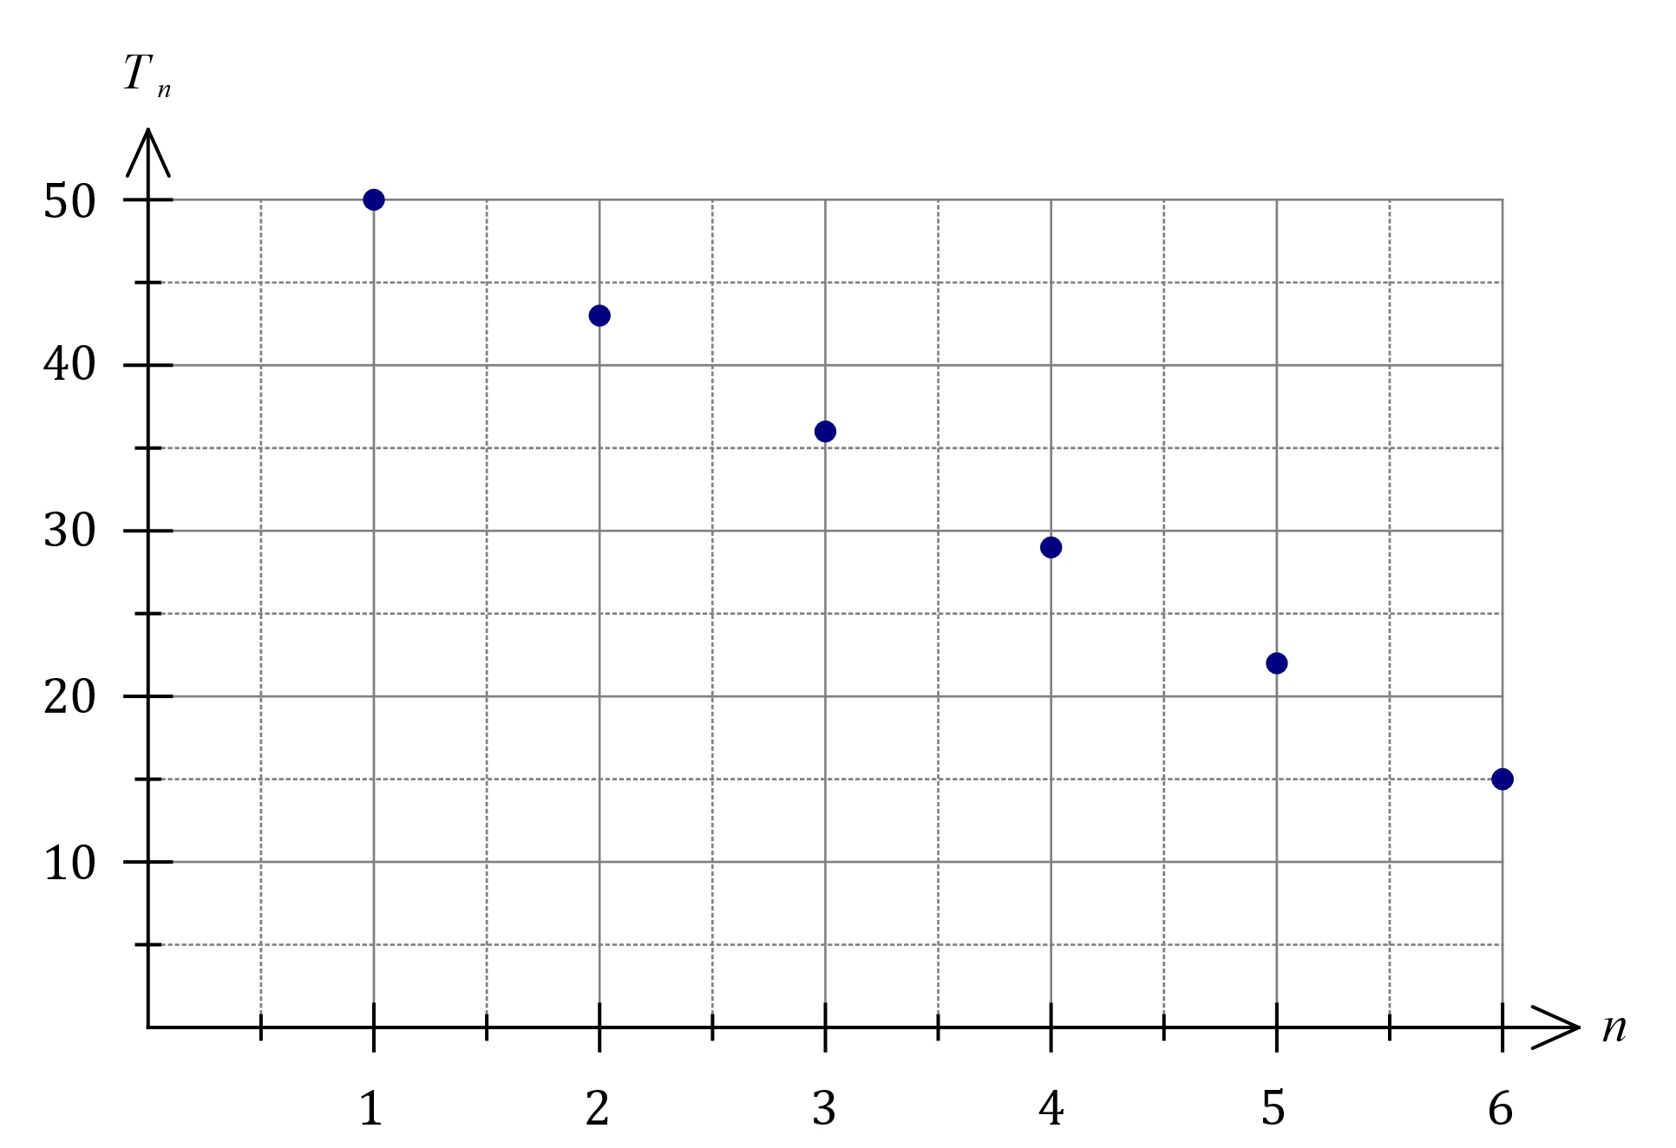

|  |
| --- |
| **Solution** |
| See graph |
| **Specific behaviours** |
| ✓ and $T_{6}$ ✓ all points plotted, no line |

(c) The rule for the $n^{th}$ term of the sequence is $T_{n}=an+b$. Determine the value of the constant $a$ and the value of the constant $b$. (2 marks)

|  |
| --- |
| **Solution** |
| $$T_{n}=50+\left(n-1\right)\left(-7\right) \\ =-7n+57$$ Hence $a=-7$ and $b=57$. |
| **Specific behaviours** |
| ✓ correctly substitutes into $n^{th}$ term rule  ✓ simplifies to show value of each constant |

Question 2 (6 marks)

Graph $G$ is shown:

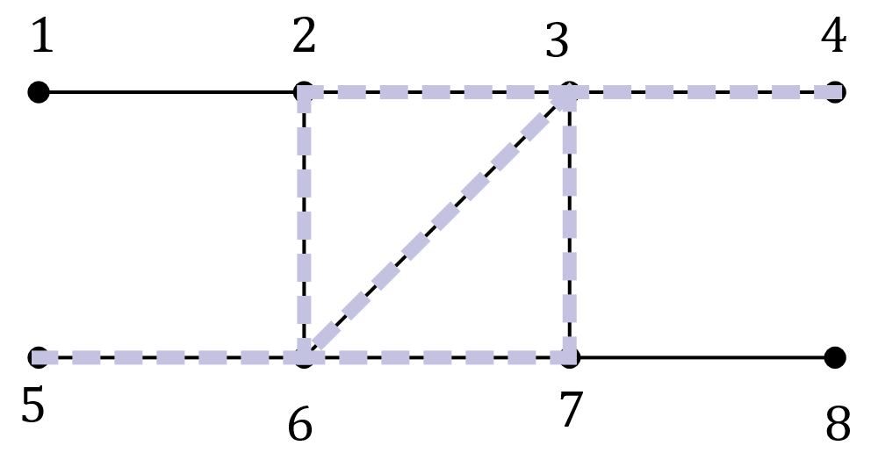

(a) State the number of edges and the number of faces in $G$ and hence show that the graph satisfies Euler's formula. (2 marks)

|  |
| --- |
| **Solution** |
| $$f=3, e=9$$ $$v+f-e=8+3-9=2$$ |
| **Specific behaviours** |
| ✓ states correct numbers  ✓ substitutes and simplifies |

(b) State the length of the longest trail in $G$ and highlight the edges in a trail of this length on the graph above. (2 marks)

|  |
| --- |
| **Solution** |
| Length is $7$ edges. |
| **Specific behaviours** |
| ✓ highlights any valid trail on graph  ✓ correct length |

(c) State the length of the longest path in $G$ and highlight the edges in a path of this length on the copy of $G$ below. (2 marks)

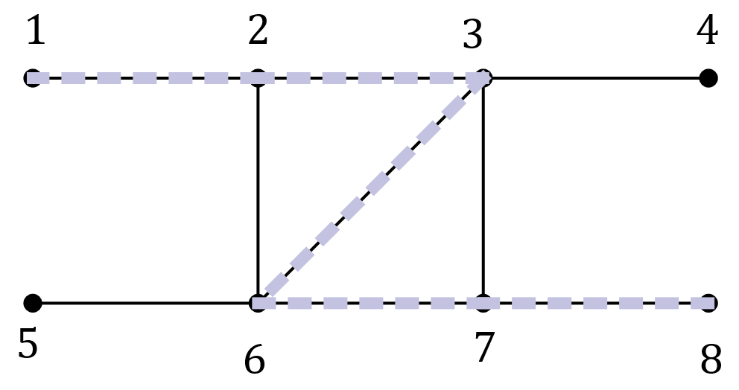

|  |
| --- |
| **Solution** |
| Length is $5$ edges. |
| **Specific behaviours** |
| ✓ highlights any valid path on graph  ✓ correct length |

Question 3 (6 marks)

A student recorded the time taken and the number of errors made when completing nine multiple choice tests, each with $40$ different questions, in the table below.

|  |  |  |  |  |  |  |  |  |  |
| --- | --- | --- | --- | --- | --- | --- | --- | --- | --- |
| Time, $t$ minutes | $$15$$ | $$22$$ | $$20$$ | $$18$$ | $$11$$ | $$15$$ | $$13$$ | $$6$$ | $$8$$ |
| Number of errors, $e$ | $$8$$ | $$4$$ | $$7$$ | $$10$$ | $$15$$ | $$13$$ | $$9$$ | $$16$$ | $$12$$ |

(a) Construct a scatterplot of this data on the axes below. (2 marks)

|  |
| --- |
| **Solution** |
| See graph |
| **Specific behaviours** |
| Correctly plots  ✓ at least $5$ points  ✓ all points |

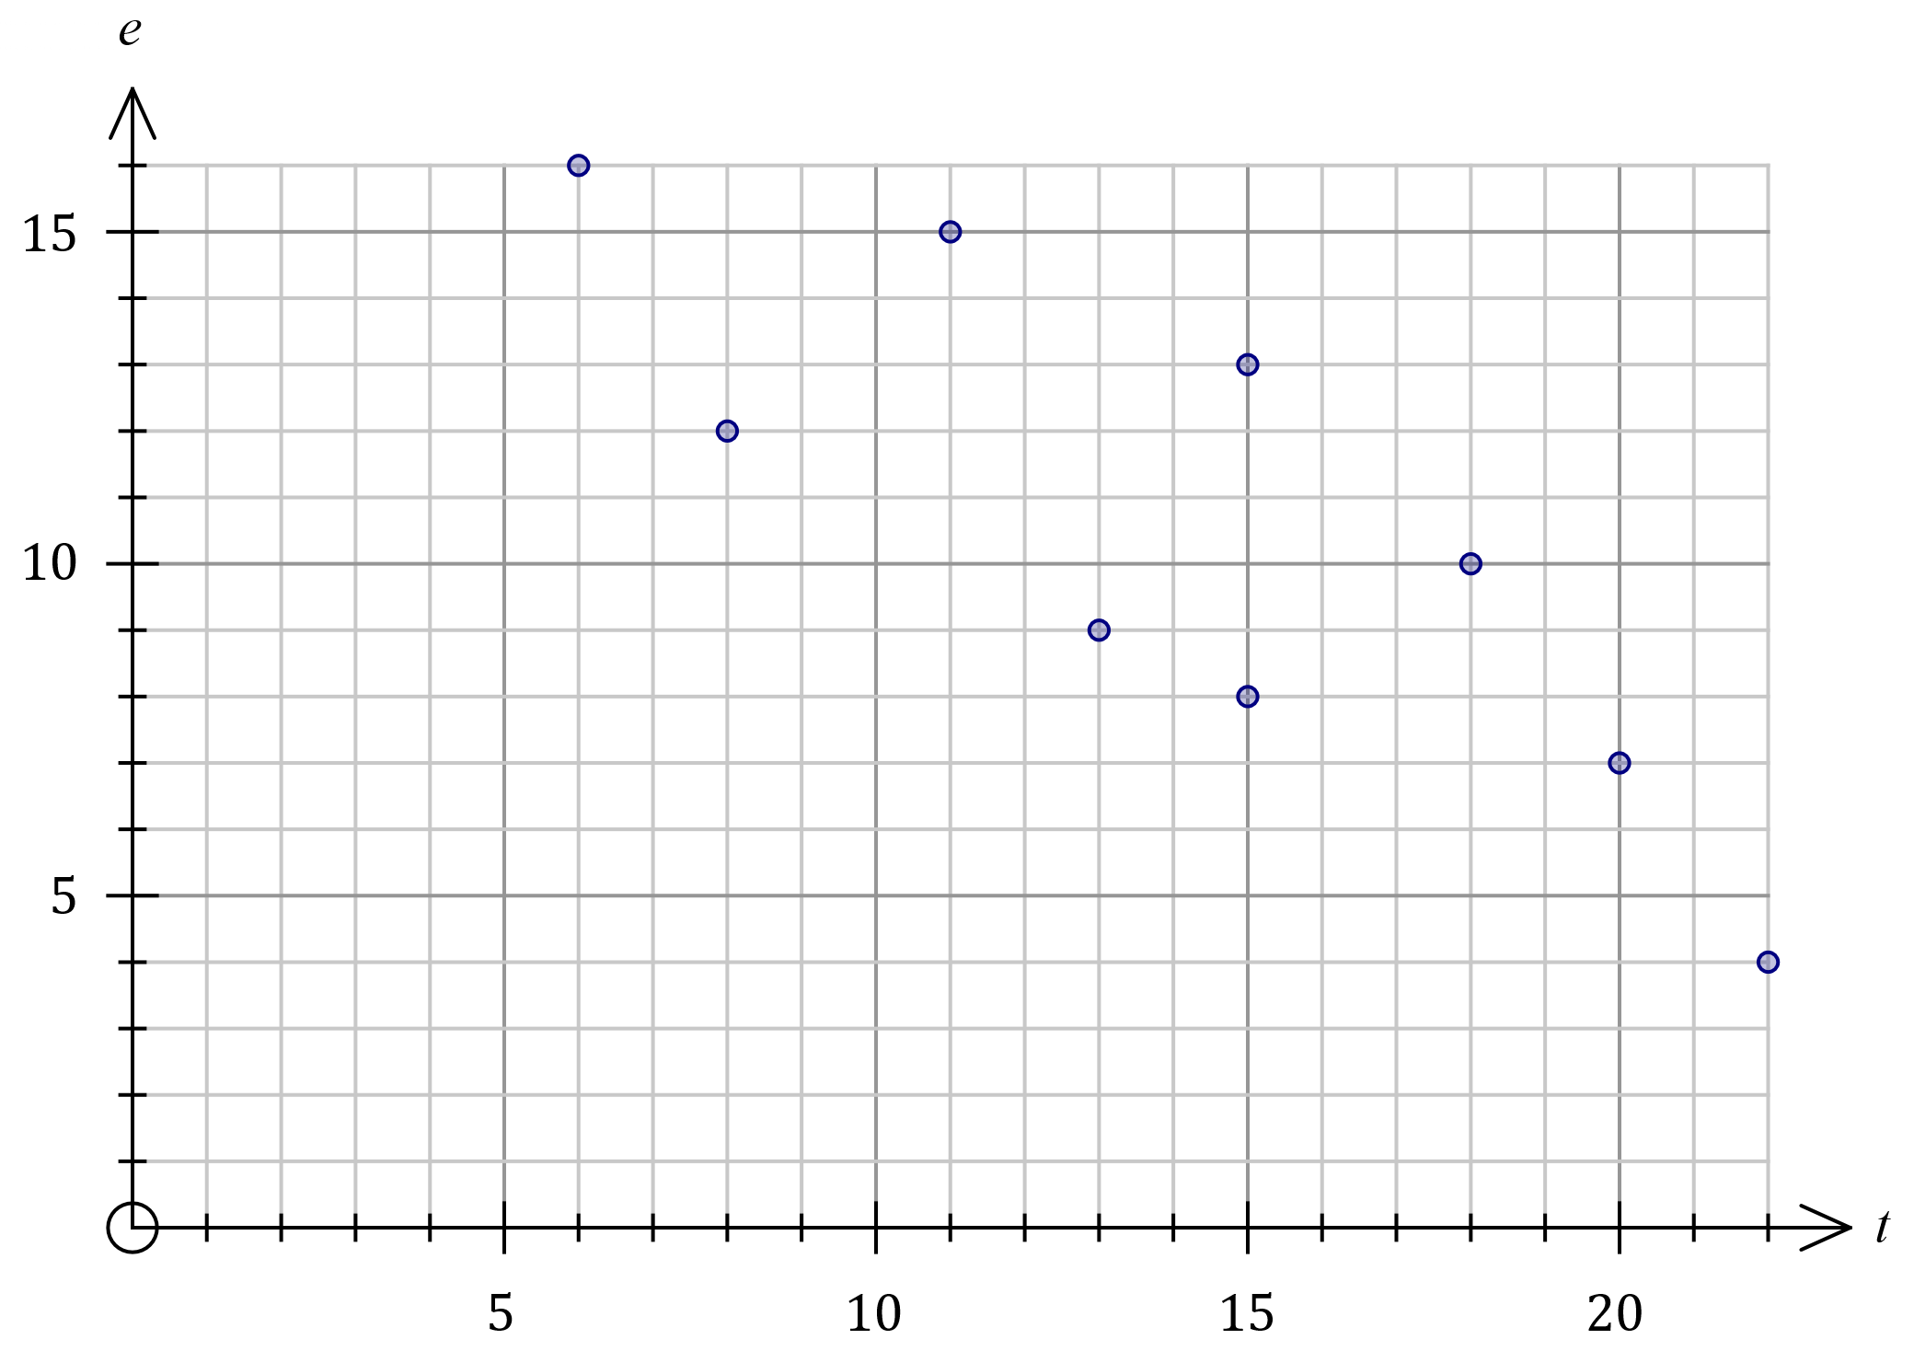

(b) Describe the strength and direction of the association between the two variables.

(2 marks)

|  |
| --- |
| **Solution** |
| The association is strong and negative. |
| **Specific behaviours** |
| ✓ describes strength as moderate or strong  ✓ describes direction as negative |

(c) The student used the data to conclude that taking more time to answer multiple choice tests caused them to answer more questions correctly. Explain whether this conclusion is justified. (2 marks)

|  |
| --- |
| **Solution** |
| There is not enough evidence to conclude that there is a causal relationship between the variables. An observed association does not always imply a causal relationship, as there may be other factors involved. |
| **Specific behaviours** |
| ✓ indicates causal relationship not justified  ✓ states observed association does not always imply causal relationship |

Question 4 (7 marks)

(a) Graph $G$ is shown below. Redraw $G$ in the plane, to clearly show that it is planar.

(1 mark)

|  |
| --- |
| **Solution** |
|  |
| **Specific behaviours** |
| ✓ correctly drawn in the plane  *Penalise once per question for vertices not drawn with solid dot* |

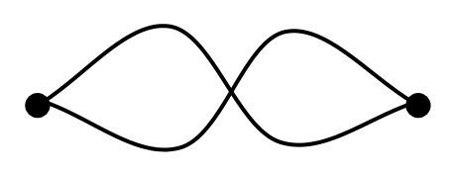

(b) Let $K_{n}$ be the complete graph with $n$ vertices. Draw, and state the number of edges in,

(i) $K_{2}$. (2 marks)

|  |
| --- |
| **Solution** |
| $K_{2}$ has $1$ edge. |
| **Specific behaviours** |
| ✓ correct graph  ✓ correct number of edges |

(ii) $K_{6}$. (2 marks)

|  |
| --- |
| **Solution** |
| $K_{6}$ has $15$ edges. |
| **Specific behaviours** |
| ✓ correct graph (all vertices order $5$)  ✓ correct number of edges |

(c) State, with reasoning, whether $K_{6}$ is a planar graph. (2 marks)

|  |
| --- |
| **Solution** |
| $K_{6}$ is not a planar graph as it cannot be drawn in the plane.  *(Also accept it cannot be drawn so that no two edges cross or only $K_{1}$ to $K_{4}$ are planar, etc.)* |
| **Specific behaviours** |
| ✓ states not planar, with reasoning  ✓ sufficient reasoning |

Question 5 (7 marks)

Bivariate data analysis of the mass $M$ g, length $L$ mm and width $W$ mm of a large number of snap peas yielded the following correlation coefficients and least-squares lines:

$$r_{WL}=0.8, L=4W+3, r_{ML}=0.7, L=15M+6.$$

(a) Determine the percentage of the variation in the lengths of these snap peas that can be explained by the variation in their masses. (2 marks)

|  |
| --- |
| **Solution** |
| $$r_{ML}^{2}={0.7}^{2}=0.49$$ $49\%$ of the variation. |
| **Specific behaviours** |
| ✓ chooses relevant coefficient  ✓ squares and states percentage |

(b) One of the least-squares lines would be better than the other as a predictor for the lengths of these snap peas. Write the equation of the line below and explain your choice.

(2 marks)

|  |
| --- |
| **Solution** |
| $$L=4W+3$$ The association between width and length is stronger than between mass and length. |
| **Specific behaviours** |
| ✓ chooses and writes relevant line  ✓ explains using strength of association |

(c) Use the equation from part (b) to predict the length of a snap pea that has a mass of $7$ g and a width of $27$ mm. (1 mark)

|  |
| --- |
| **Solution** |
| $$L=4\left(27\right)+3=111 \text{mm}$$ |
| **Specific behaviours** |
| ✓ calculates length |

(d) Explain why it is difficult to comment on the validity of the prediction made in part (c).

(2 marks)

|  |
| --- |
| **Solution** |
| Reasonably strong association between the variables supports the validity. However, there is no way of telling if the prediction involves extrapolation, and extrapolation would invalidate the prediction. Hence difficult to comment. |
| **Specific behaviours** |
| ✓ indicates strength of association supports validity  ✓ indicates no data to check for extrapolation |

Question 6 (7 marks)

(a) Digraph $G_{1}$ is shown. Complete the adjacency matrix $M$ for $G_{1}$. (2 marks)

|  |  |  |  |
| --- | --- | --- | --- |
| $$M$$ | $$A$$ | $$B$$ | $$C$$ |
| $$A$$ | $$2$$ | $$1$$ | $$1$$ |
| $$B$$ | $$0$$ | $$0$$ | $$1$$ |
| $$C$$ | $$1$$ | $$0$$ | $$0$$ |

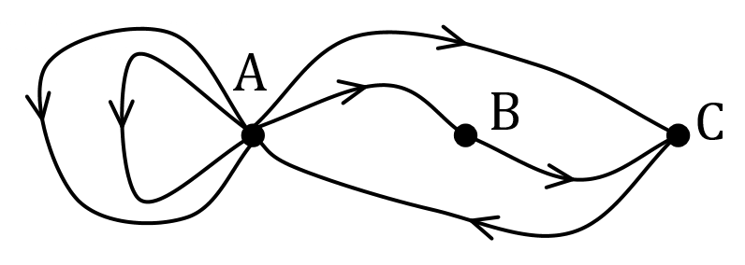

|  |
| --- |
| **Solution** |
| See matrix |
| **Specific behaviours** |
| ✓ one row correct  ✓ all rows correct |

(b) The adjacency matrix $A$ for the non-directed graph $G_{2}$ with $4$ vertices is shown below.

$$A=\left[\begin{matrix}1 & 3 & 1 & 0 \\ 3 & 0 & 1 & 0 \\ 1 & 1 & 0 & 2 \\ 0 & 0 & 2 & 1\end{matrix}\right]$$

(i) $G_{3}$ is a subgraph of $G_{2}$, and has $4$ vertices $.$ State, with reasoning, the minimum number of edges that must be removed from $G_{2}$ so that $G_{3}$ is a simple graph.

(3 marks)

|  |
| --- |
| **Solution** |
| $a_{1,1}$ and $a_{4,4}$ indicate $2$ loops. $a_{1,2}$ and $a_{3,4}$ indicate $2+1=3$ multiple edges.  Hence remove $2+3=5$ edges. |
| **Specific behaviours** |
| ✓ identifies loops  ✓ identifies multiple edges  ✓ correct number of edges |

(ii) In the matrix $A^{4},$ the entry $a_{3,2}=68$. Use precise terminology associated with graphs to fully explain the meaning of this entry in $A^{4}$. (2 marks)

|  |
| --- |
| **Solution** |
| $G_{2}$ contains $68$ different walks of length $4$ between vertices $2$ and $3$. |
| **Specific behaviours** |
| ✓ states any two of below  ✓ states all three $68$  * is the number of different **walks** (NOT paths, ways, etc) * length of each walk is $4$* from/to vertices (*order not important as symmetrical*) |

Question 7 (6 marks)

The scatterplot below shows data from $25$ samples drawn from different suburbs in a city. The variables are the percentage of people in each sample who have grey hair ($x$) and who have heart disease ($y$).

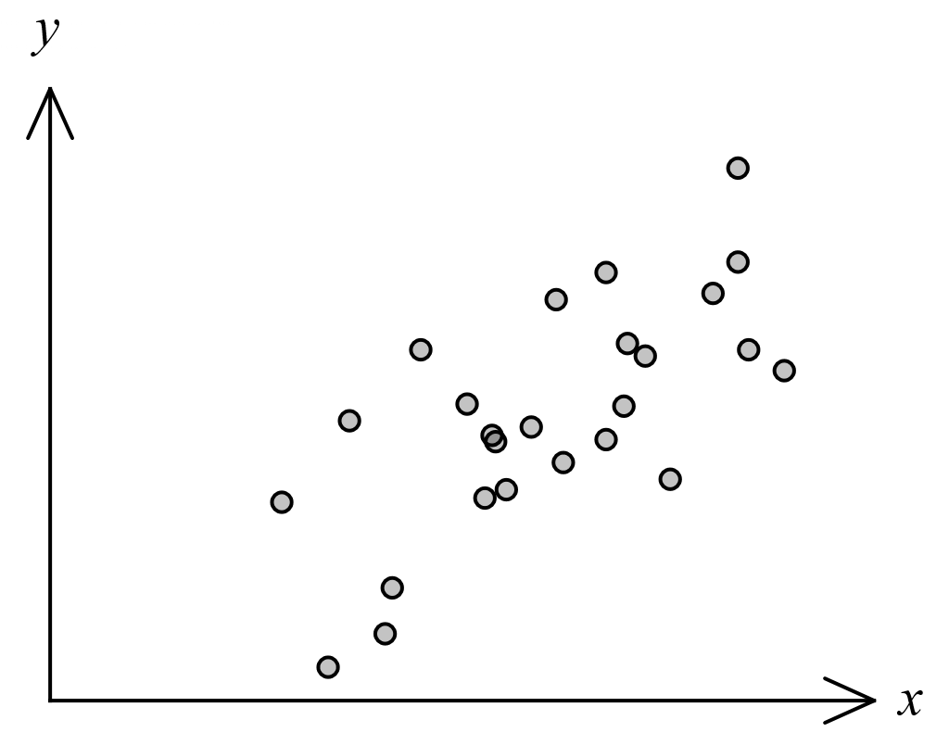

(a) The correlation coefficient $r_{xy}$ for this data is one of $0.7, 0.4 , 0.2, -0.2, -0.4, -0.7$.  
State $r_{xy}$ and explain your choice. (2 marks)

|  |
| --- |
| **Solution** |
| $r_{xy}=0.7$- the association is positive and moderate. |
| **Specific behaviours** |
| ✓ correct value  ✓ explains using direction and strength |

(b) The least-squares line for the data is $y=ax+b$, where $a$ and $b$ are constants.

(i) State the name of the response variable for this least-squares line. (1 mark)

|  |
| --- |
| **Solution** |
| Response variable is heart disease, or $y$. |
| **Specific behaviours** |
| ✓ states name or variable |

(ii) Explain whether the variable $a$ would be a positive or negative number. (1 mark)

|  |
| --- |
| **Solution** |
| $a$ would be a positive number as association is positive. |
| **Specific behaviours** |
| ✓ states positive with reason |

(c) Identify and explain a possible non-causal explanation for the observed association between the variables in this data. (2 marks)

|  |
| --- |
| **Solution** |
| The age of people in each sample may be a confounding variable. The two variables are more likely to have a causal association with age rather than with each other. |
| **Specific behaviours** |
| ✓ states age or another confounding variable  ✓ explains common response to age |

|  |
| --- |
| **Alternative Solution** |
| The observed association may be coincidental. Coincidental associations more likely with smaller sample sizes, and here the sample is only $25$. |
| **Specific behaviours** |
| ✓ states coincidence  ✓ suitable explanation |

Question 8 (6 marks)

(a) Let $K_{m,n}$ be the complete bipartite graph with $m$ vertices in one set and $n$ vertices in the second set. Draw $K_{2,3}$ and explain whether $K_{2,3}$ is Hamiltonian, semi-Hamiltonian or neither. (3 marks)

|  |
| --- |
| **Solution** |
| $K_{2,3}$ is semi-Hamiltonian as it contains a Hamiltonian path (example path highlighted) but not a Hamiltonian cycle. |
| **Specific behaviours** |
| ✓ draws complete bipartite graph  ✓ states semi-Hamiltonian  ✓ reasonable explanation |

(b) The vertices and edges in the graph below represent students and friendships, respectively. Determine whether it is possible for the students to sit in a circle so that every student is sitting between two friends. If it is possible, explain why and draw a possible seating plan. If it is not possible, explain why. (3 marks)

|  |
| --- |
| **Solution** |
| It is possible as the graph contains a Hamilton cycle. |
| **Specific behaviours** |
| ✓ identifies Hamilton cycle  ✓ states it is possible  ✓ draws correct plan |

